BUG-01
[Header] Cart icon is displayed in the wrong position, after opening any page, while logged in as visual_user
Description:
The cart icon is displayed lower and further left than its normal position in the header. On the Products page it sits right above the sort dropdown. The same happens on the Product Details, Cart, Checkout, and Dynamic Catalog pages.
Environment: Web - Chrome, Windows, https://www.saucedemo.com
Preconditions:
1. User is logged in as visual_user
Steps:
1. Open https://www.saucedemo.com
2. Login with username "visual_user" and password "secret_sauce"
3. Check the position of the cart icon in the header of the Products page
4. Open a product details page, the Cart page, and the Checkout pages, and check the icon again
Expected result:
1. The cart icon is displayed at the top right of the header, on the same line as the menu icon and the "Swag Labs" title
2. The icon is in the same position on every page
Actual result:
1. The cart icon is displayed below the header line, close to the sort dropdown on the Products page
2. The cart badge (number of items) moves together with the icon
3. The same wrong position appears on all pages
Attachments:
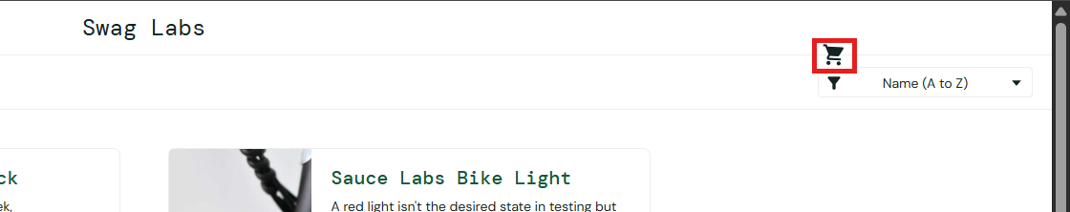
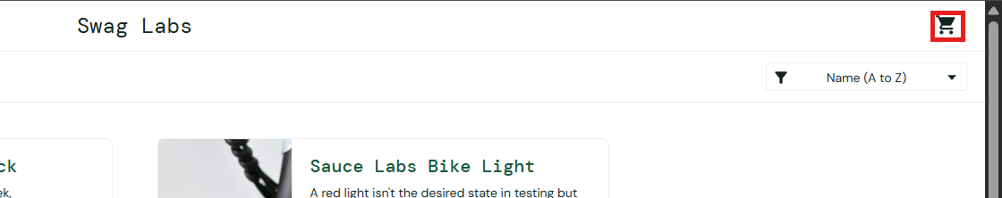

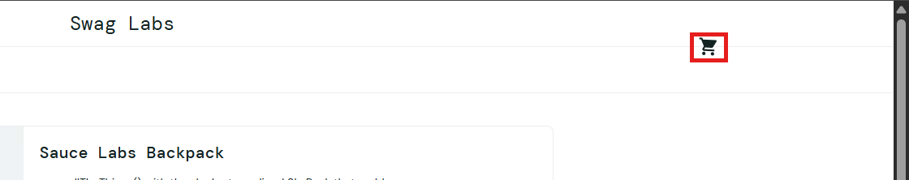

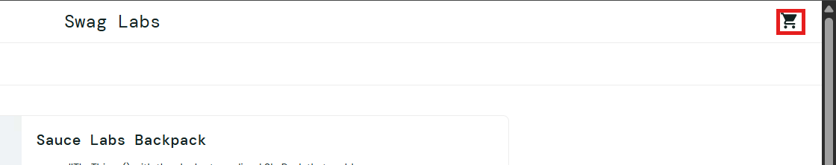
Severity: Medium
Priority: High

BUG-02
[Products] Dog image is displayed instead of the product image, after opening the Products page, while logged in as visual_user
Description:
The first product in the list shows a photo of a dog holding a tennis ball instead of its real product image. The correct image is displayed on the product details page.
Environment: Web - Chrome, Windows, https://www.saucedemo.com
Preconditions:
1. User is logged in as visual_user
Steps:
1. Open https://www.saucedemo.com
2. Login with username "visual_user" and password "secret_sauce"
3. Check the product images on the Products page
4. Change the sort option and check the images again
Expected result:
1. Each product shows its own image
2. Sauce Labs Backpack shows the backpack image
Actual result:
1. The first product in the list shows a photo of a dog holding a tennis ball
2. With Name (A to Z) the dog image is on Sauce Labs Backpack, and with Name (Z to A) it is on Test.allTheThings() T-Shirt (Red)
3. The product details page shows the correct image
Attachments:
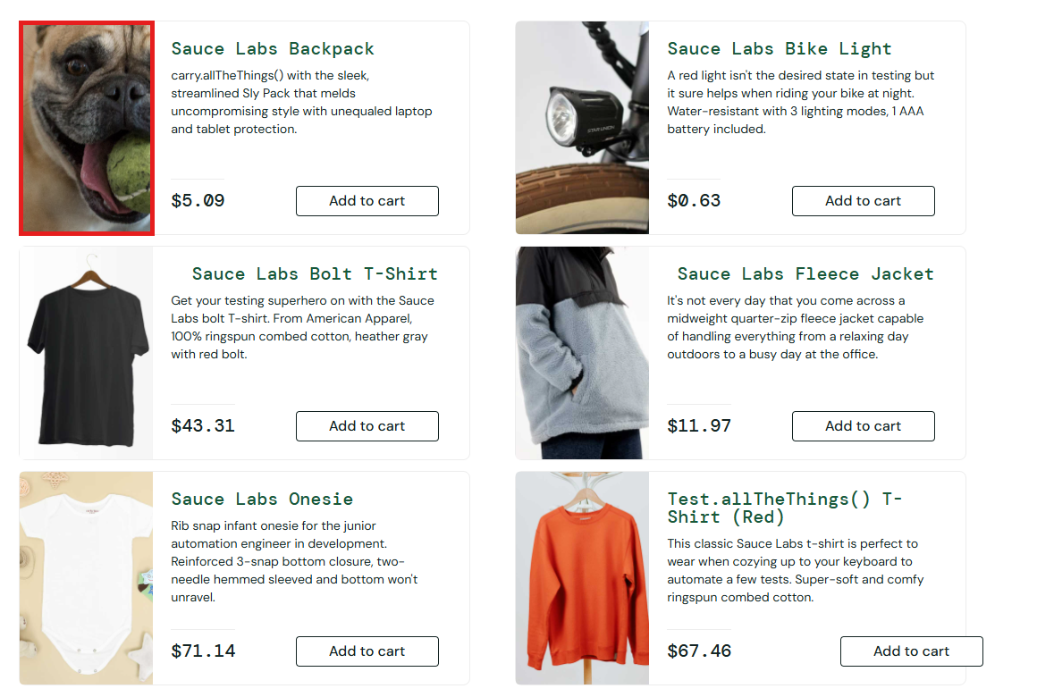
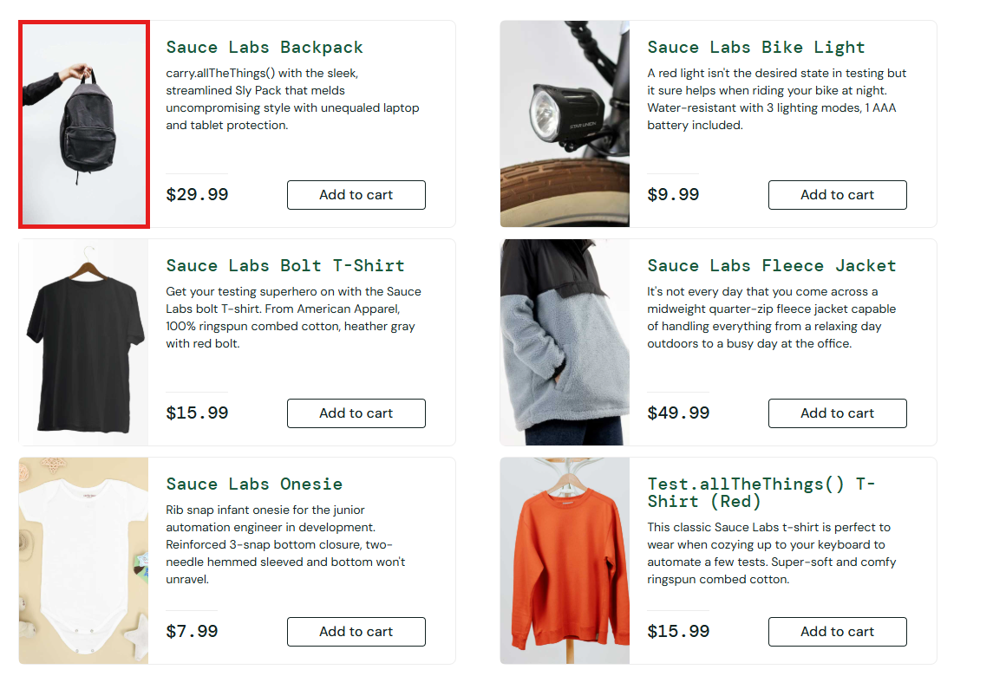

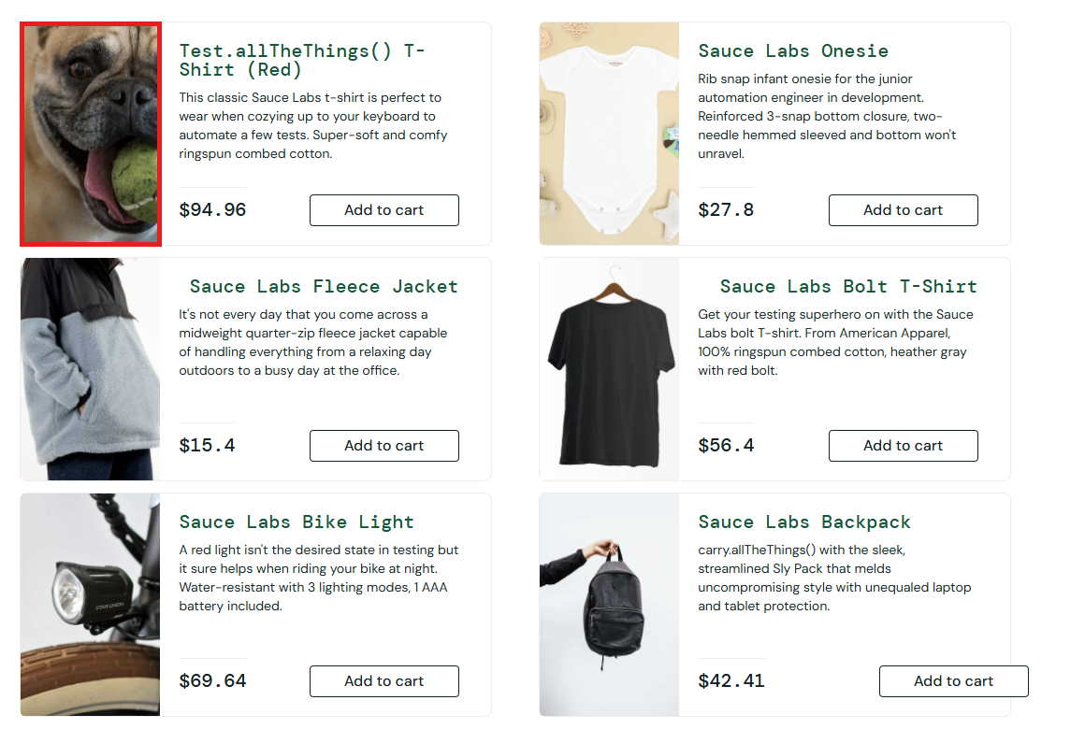
Severity: Medium
Priority: High

BUG-03
[Products] Product prices are wrong and change after every reload, after opening the Products page, while logged in as visual_user
Description:
None of the prices on the Products page match the real prices, and the displayed price of the same product is different each time the page is loaded.
Environment: Web - Chrome, Windows, https://www.saucedemo.com
Preconditions:
1. User is logged in as visual_user
Steps:
1. Open https://www.saucedemo.com
2. Login with username "visual_user" and password "secret_sauce"
3. Check the price of each product on the Products page
4. Refresh the page (F5) and check the prices again
5. Repeat the refresh two more times
Expected result:
1. Prices are: Sauce Labs Backpack $29.99, Sauce Labs Bike Light $9.99, Sauce Labs Bolt T-Shirt $15.99, Sauce Labs Fleece Jacket $49.99, Sauce Labs Onesie $7.99, Test.allTheThings() T-Shirt (Red) $15.99
2. The prices stay the same after every reload
Actual result:
1. The displayed prices do not match the real prices (for example Backpack $5.09, Bike Light $0.63, Bolt T-Shirt $43.31)
2. The price of the same product changes between page loads (Sauce Labs Backpack: $5.09, then $3.64, then $15.82)
Attachments:
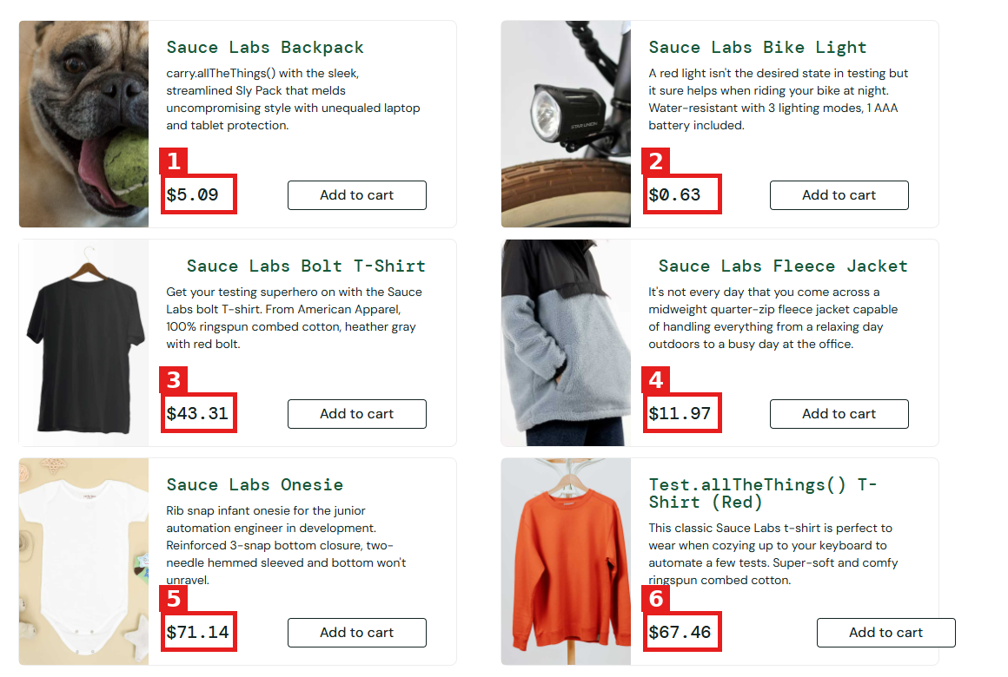
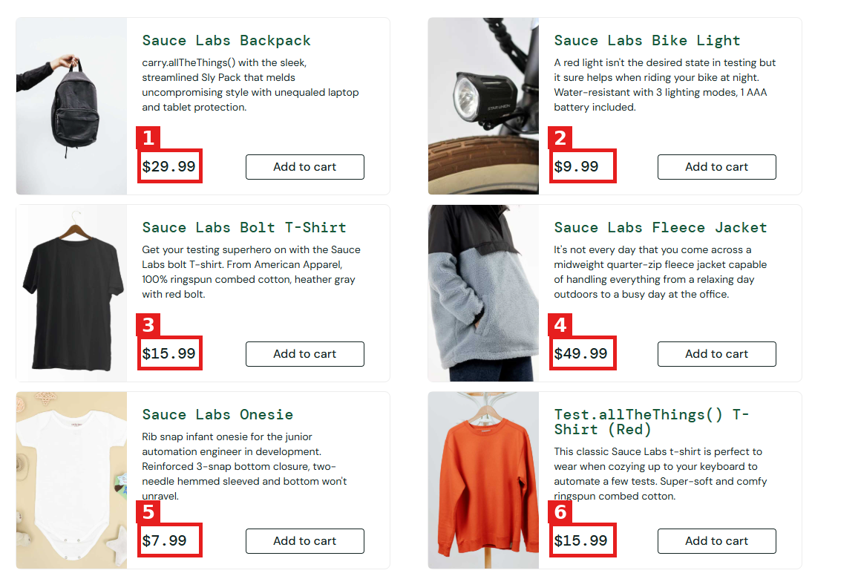

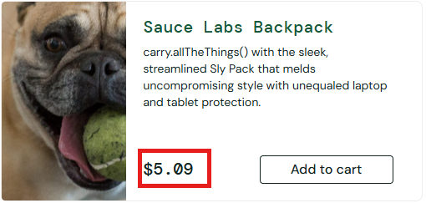
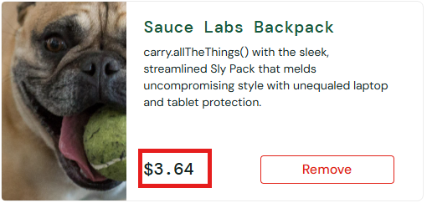
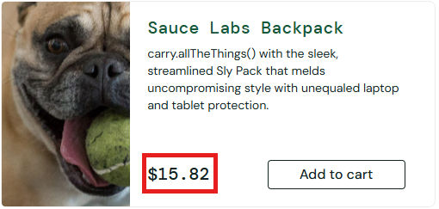

Severity: High
Priority: High

BUG-04
[Products] Some prices are displayed with one decimal digit, after selecting a sort option, while logged in as visual_user
Description:
Some prices lose the last zero and are displayed with one digit after the decimal point, while the rest of the site always shows two digits.
Environment: Web - Chrome, Windows, https://www.saucedemo.com
Preconditions:
1. User is logged in as visual_user
Steps:
1. Open https://www.saucedemo.com
2. Login with username "visual_user" and password "secret_sauce"
3. Select Name (Z to A) and check the price format
4. Select Price (low to high) and check the price format
5. Select Price (high to low) and check the price format
Expected result:
1. Every price is displayed with two digits after the decimal point (for example $27.80)
Actual result:
1. Name (Z to A): $27.8, $15.4, and $56.4
2. Price (low to high): $87.3
3. Price (high to low): $99.3
Attachments:
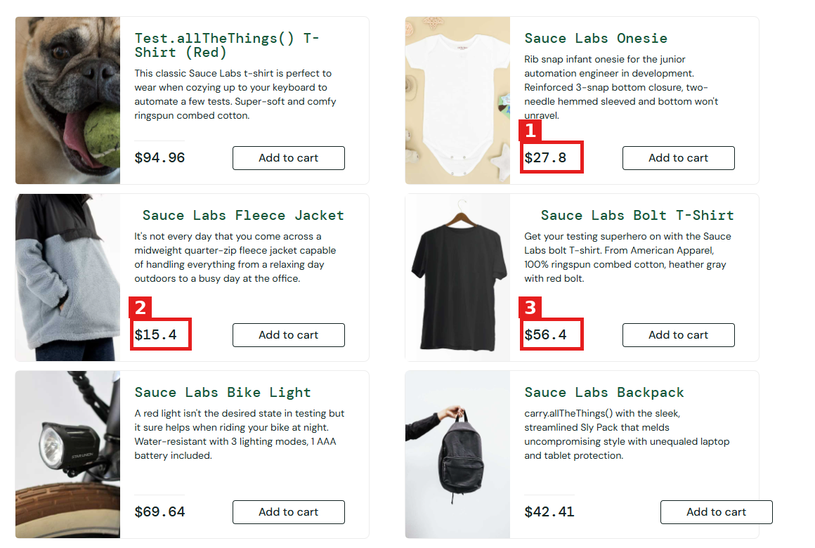

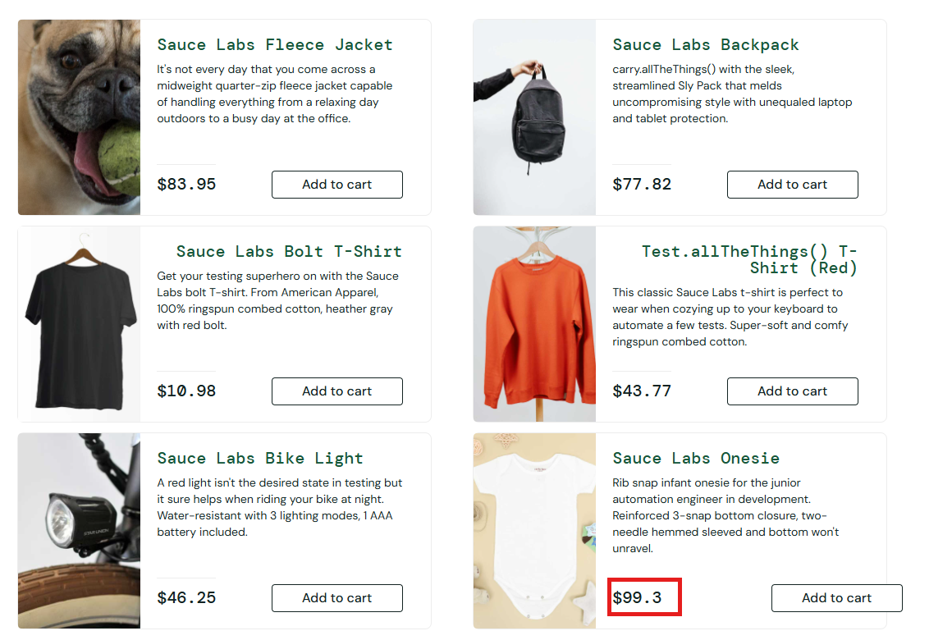
Severity: Low
Priority: Low

BUG-05
[Products] Products are not sorted by the displayed prices, after selecting Price (low to high) or Price (high to low), while logged in as visual_user
Description:
The sort by price does not match the order of the displayed prices in either direction.
Environment: Web - Chrome, Windows, https://www.saucedemo.com
Preconditions:
1. User is logged in as visual_user
Steps:
1. Open https://www.saucedemo.com
2. Login with username "visual_user" and password "secret_sauce"
3. Select Price (low to high) and check the order of the prices
4. Select Price (high to low) and check the order of the prices
Expected result:
1. Price (low to high): products are sorted from the lowest price ($7.99) to the highest price ($49.99)
2. Price (high to low): products are sorted from the highest price ($49.99) to the lowest price ($7.99)
Actual result:
1. Price (low to high) shows $76.96, $4.37, $33.22, $59.65, $75.82, $87.3, which is not in ascending order
2. Price (high to low) shows $83.95, $77.82, $10.98, $43.77, $46.25, $99.3, which is not in descending order
3. The order of the products themselves is correct (the same order as standard_user), but the displayed prices do not follow it
Attachments:
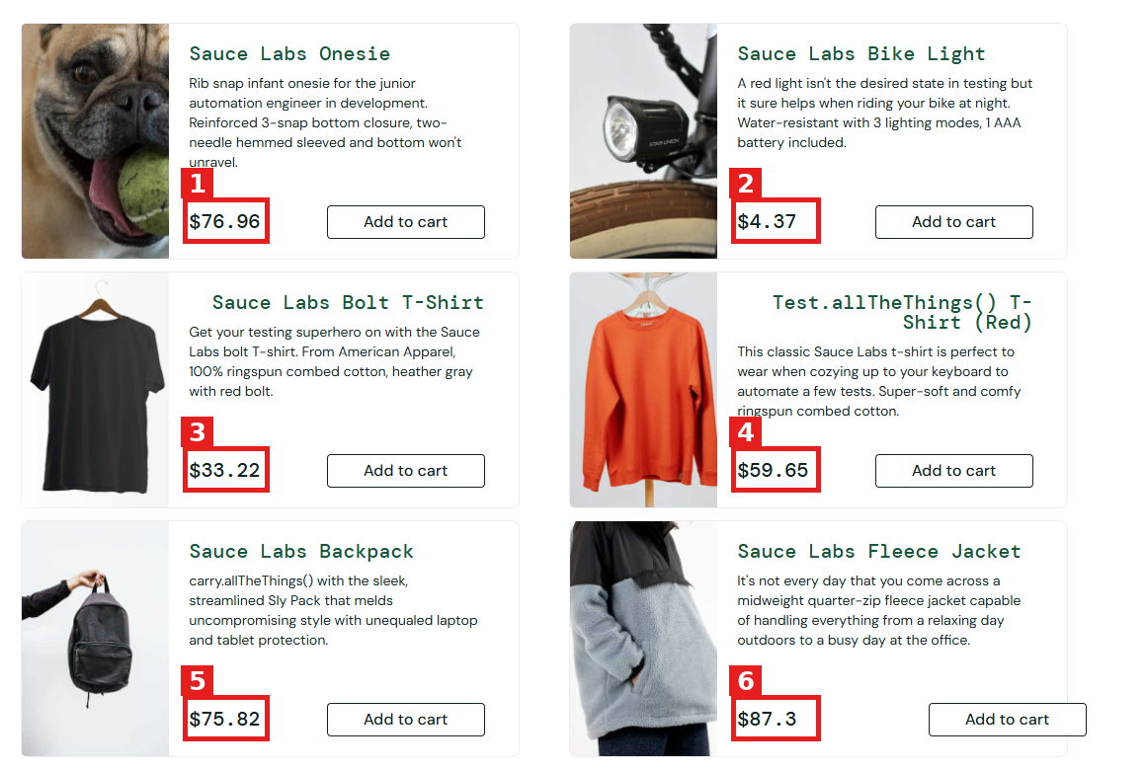
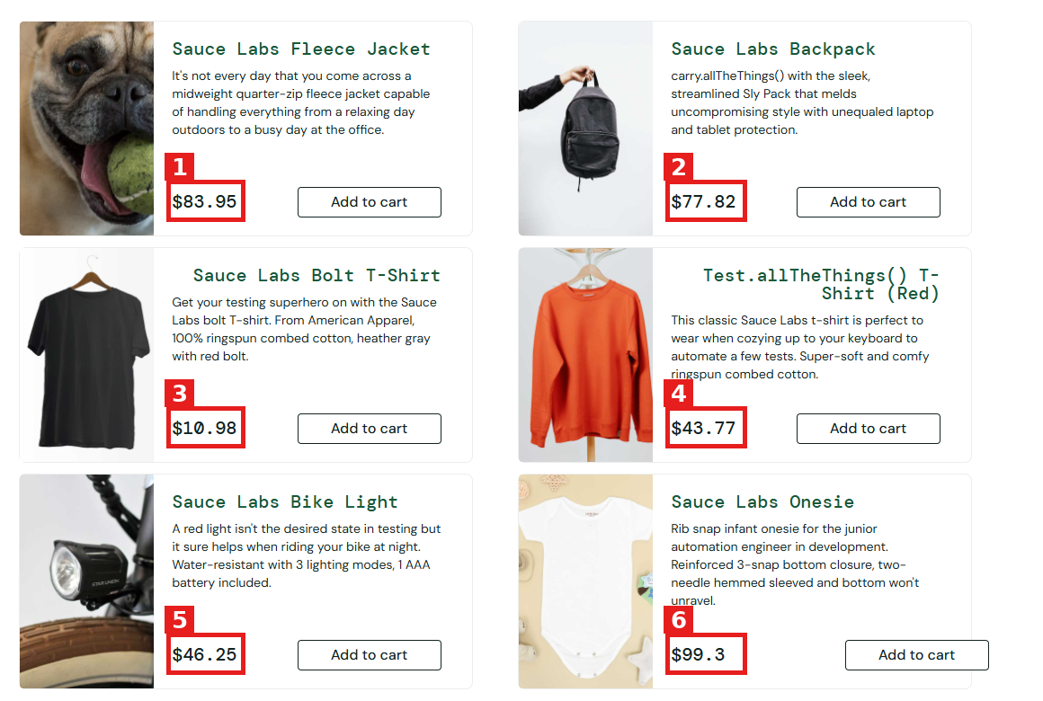
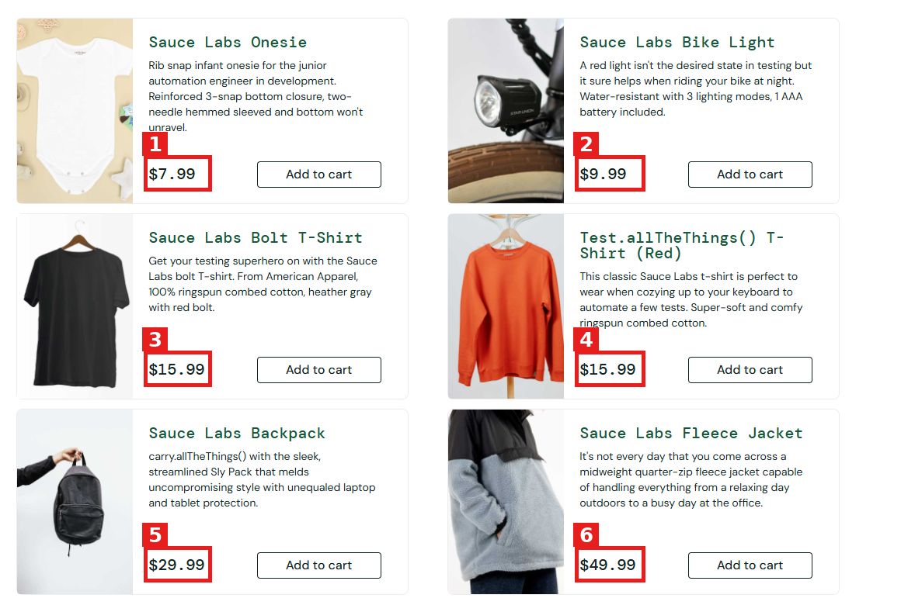
Severity: Medium
Priority: Medium

BUG-06
[Products] Prices on the Products page do not match the Product Details and Cart pages, after adding products to the cart, while logged in as visual_user
Description:
The same product shows a different price on the Products page than on the Cart page and the Product Details page.
Environment: Web - Chrome, Windows, https://www.saucedemo.com
Preconditions:
1. User is logged in as visual_user
Steps:
1. Open https://www.saucedemo.com
2. Login with username "visual_user" and password "secret_sauce"
3. Click Add to cart on Sauce Labs Backpack and Sauce Labs Bike Light
4. Note the prices of both products on the Products page
5. Open the Cart page and note the prices
6. Open the Sauce Labs Backpack details page and note the price
Expected result:
1. The price of each product is the same on the Products page, the Cart page, and the Product Details page (Backpack $29.99, Bike Light $9.99)
Actual result:
1. Products page: Backpack $3.64 and Bike Light $70.19
2. Cart page: Backpack $29.99 and Bike Light $9.99
3. Product Details page: Backpack $29.99
Attachments:
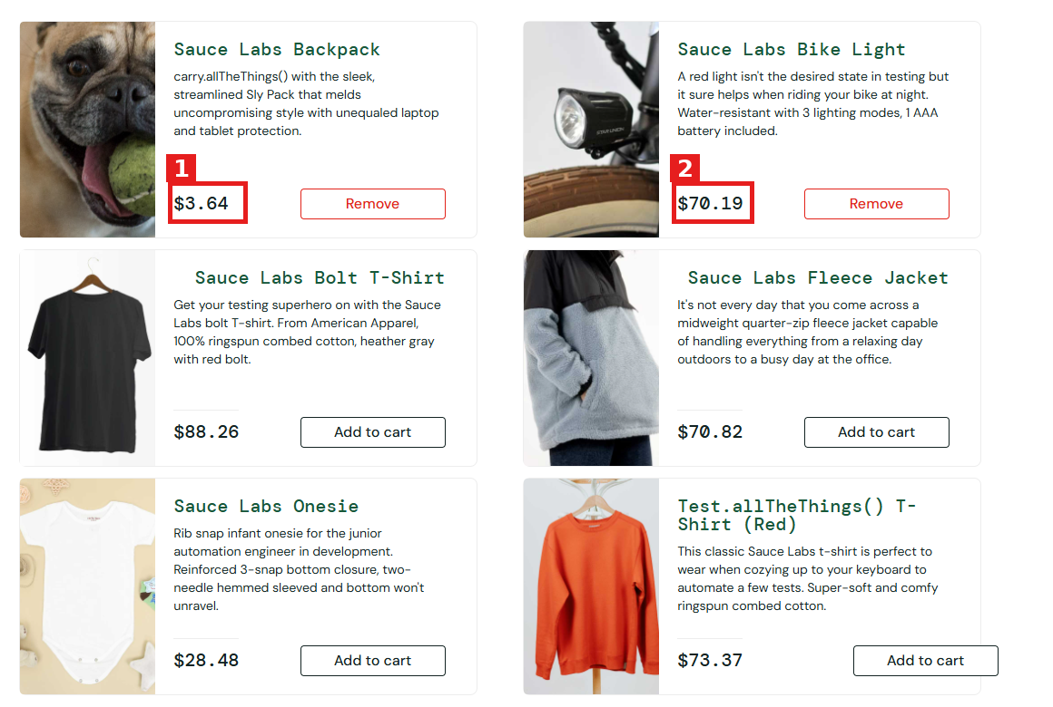
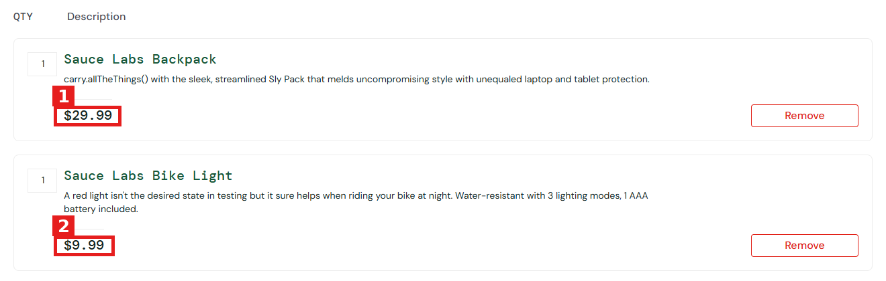
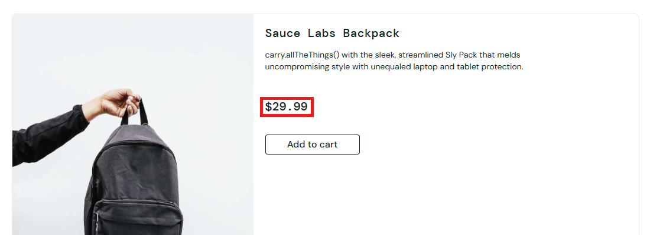
Severity: High
Priority: High

BUG-07
[Products] Add to cart button of the last product is displayed outside the card, after opening the Products page, while logged in as visual_user
Description:
The Add to cart button of the last product (bottom right) goes beyond the right edge of its card.
Environment: Web - Chrome, Windows, https://www.saucedemo.com
Preconditions:
1. User is logged in as visual_user
Steps:
1. Open https://www.saucedemo.com
2. Login with username "visual_user" and password "secret_sauce"
3. Scroll to the last product card on the Products page
4. Check the position of its Add to cart button
5. Change the sort option and check the last card again
Expected result:
1. The Add to cart button is displayed inside the bottom right corner of every card, including the last one
Actual result:
1. The Add to cart button of the last product is displayed outside the right edge of the card
2. It happens with every sort option, on whichever product is last
Attachments:
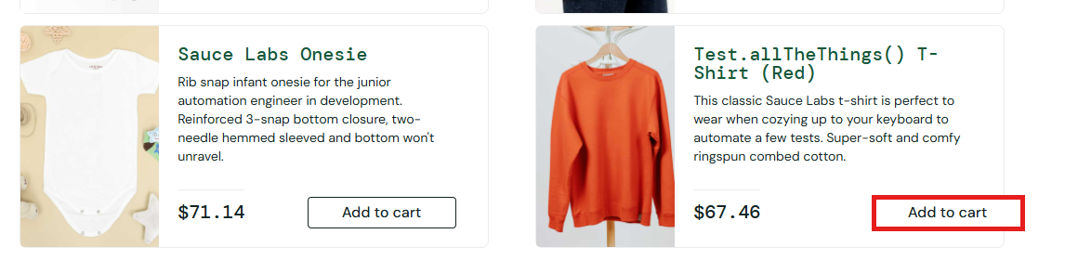
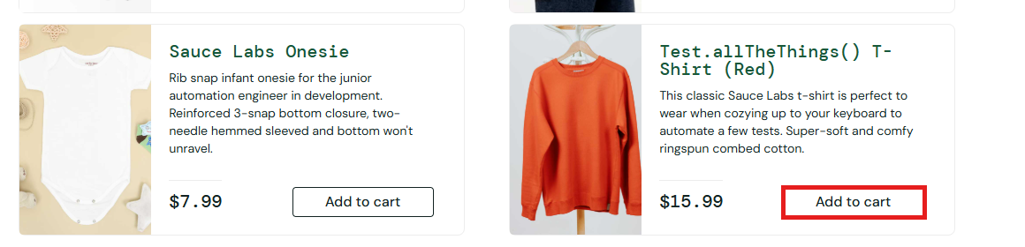
Severity: Medium
Priority: Medium

BUG-08
[Products] Product names are misaligned inside the cards, after opening the Products page, while logged in as visual_user
Description:
Some product names are shifted from the normal left position inside their cards.
Environment: Web - Chrome, Windows, https://www.saucedemo.com
Preconditions:
1. User is logged in as visual_user
Steps:
1. Open https://www.saucedemo.com
2. Login with username "visual_user" and password "secret_sauce"
3. Select Name (A to Z) and check the position of the product names in all six cards
Expected result:
1. All product names start at the same left position inside their cards and are left-aligned
Actual result:
1. Name (A to Z): Sauce Labs Bolt T-Shirt and Sauce Labs Fleece Jacket start further right than the other names
Attachments:
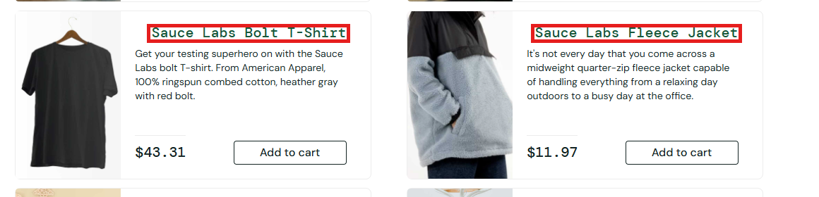
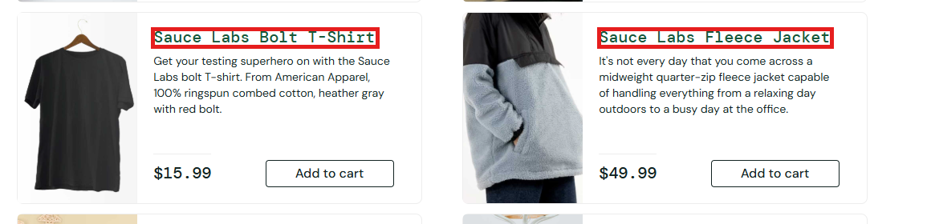
Severity: Low
Priority: Low

BUG-09
[Cart] Checkout button is displayed in the header area, after opening the Cart page, while logged in as visual_user
Description:
The Checkout button is displayed in the top right corner, over the header area, instead of below the product list.
Environment: Web - Chrome, Windows, https://www.saucedemo.com
Preconditions:
1. User is logged in as visual_user
Steps:
1. Open https://www.saucedemo.com
2. Login with username "visual_user" and password "secret_sauce"
3. Click the cart icon with an empty cart and check the Checkout button position
4. Add products to the cart, open the Cart page, and check the button position again
Expected result:
1. The Checkout button is displayed at the bottom right of the product list, on the same line as the Continue Shopping button
Actual result:
1. The Checkout button is displayed at the top right corner, next to the header
2. It happens with an empty cart and with products in the cart
Attachments:
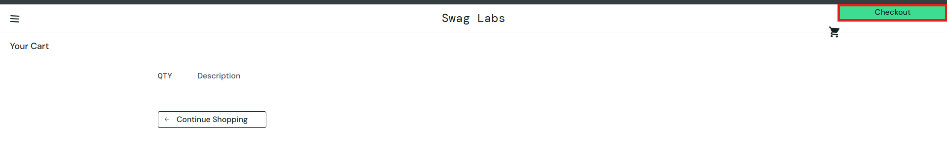
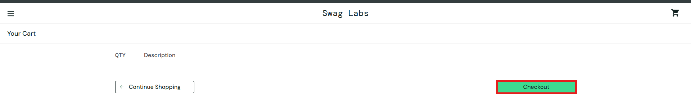

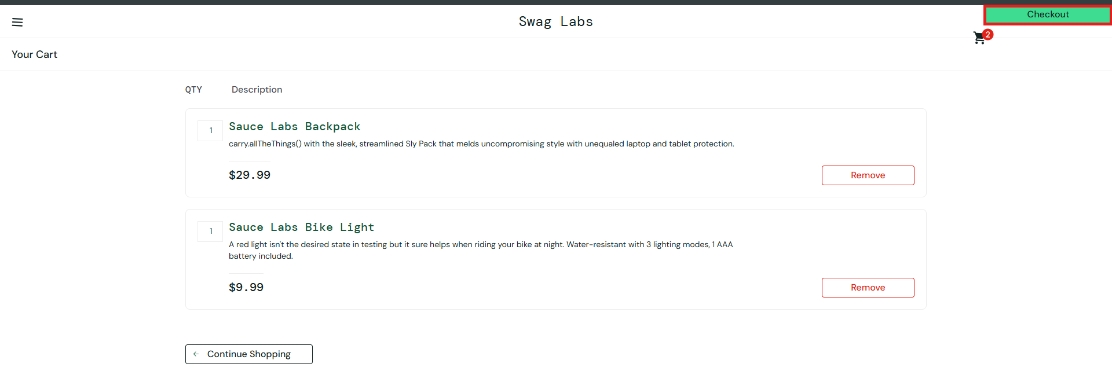
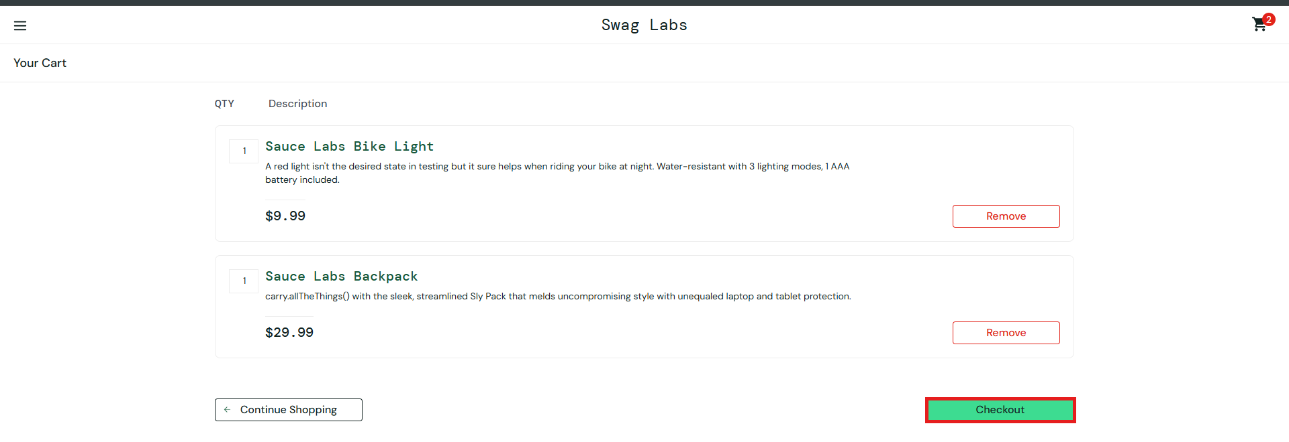
Severity: Medium
Priority: Medium

BUG-10
[Header] Menu (burger) icon is tilted, after opening any page, while logged in as visual_user
Description:
The menu icon is tilted instead of being straight. The other icons inside the menu are displayed correctly.
Environment: Web - Chrome, Windows, https://www.saucedemo.com
Preconditions:
1. User is logged in as visual_user
Steps:
1. Open https://www.saucedemo.com
2. Login with username "visual_user" and password "secret_sauce"
3. Check the menu icon at the top left of the header
4. Click the menu icon to open the side navigation menu
5. Check the other icons inside the menu
Expected result:
1. The menu icon (hamburger icon) shows three straight horizontal lines
2. The other icons inside the menu are straight and properly aligned
Actual result:
1. The lines of the menu icon are tilted and uneven
Attachments:



Severity: Low
Priority: Low

